Linux Fundamentals

Assignment 1

Shreyyash Sharma

14 April

2020

Contents

1. Assignment 1: Understanding Swap Partition
   1. Introduction
   2. Answer
      1. Create Swap Partition……………………………… 3
      2. Prepare for Swap………………………………….. ... 4
      3. Determine UUID…………………………………… 4
      4. Add to /etc/fstab…………………………………… 5
      5. Current Swap Memory……………………………… 6
      6. Activate and Verify New Swap……………………… 6

List of figures

1.2.1 Figure 1: Create a new partition of 256 MB…………..…………… 3

1.2.1 Figure 2: Change type to Swap..….……………….……………….. 4

1.2.2 Figure 3: Prepare for Swap..……………………..……………….… 4

1.2.4 Figure 4: Add UUID to /etc/ftstab………………………...………. 5

1.2.5 Figure 5: Current Swap Memory…………………………………… 6

1.2.6 Figure 6: New Swap Memory……………….……………………… 6

CHAPTER1

Assignment 1: Understanding Swap Partition

* 1. Introduction

A Swap partition acts as an overflow memory space to the RAM. It acts as an intermediary to the RAM and Secondary storage. When a Linux machine is hibernated, the data is stored in Swap partition since the RAM is Volatile in nature.

1.2 Answer 1

1.2.1 Create swap partition

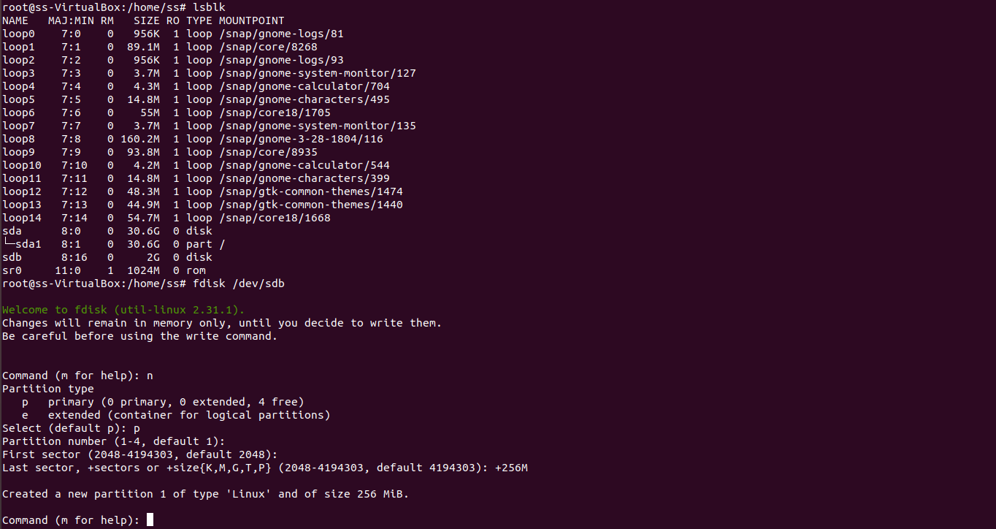

*Figure 1: Create a new partition of 256 MB*

The partition can be created using the commands

**lsblk** - identify the partition name, in this case /sdb

**fdisk /dev/sdb** - open fdisk util for creating partition

**n** - create new partition

**p** - primary

**+256M** - size

The partition is set for creation and changes not yet written to drive.

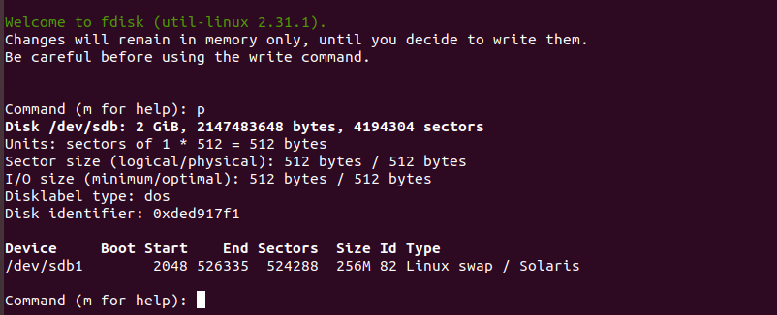

*Figure 2: Change type to Swap*

The type of partition can be changed within fdisk util by the following cmds

**t** - change partition type, type 82 is partition type number for swap

1.2.2 Prepare for Swap

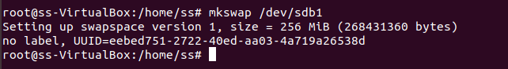

*Figure 3: Preparing for Swap*

The cmd for preparing for swap is as follows

**mkswap /dev/sdb1** - make the given partition as swap

1.2.3 Determine UUID

The UUID is displayed when the mkswap command is used. UUID of out swap is **eebed751-2722-40ed-aa03-4a719a26538d.**

1.2.4 Add to /etc/fstab

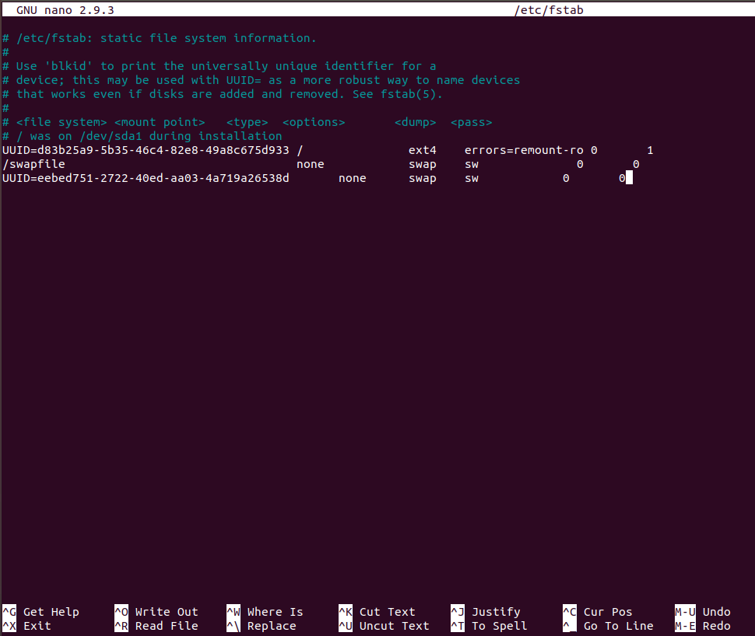

*Figure 3: Add UUID to /etc/fstab file*

The /etc/fstab file was opened using the command

**nano /etc/fstab** - file editor, file location

1.2.5 Current swap Memory

*Figure 4: Current Swap Memory*

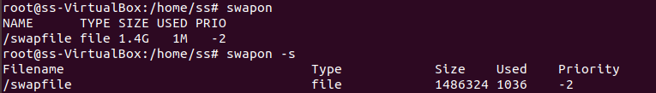

The current swap memory can be checked using the command

**swapon –s** - Display current swap space

1.2.6 Activate and Verify New Swap

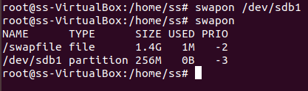

*Figure 5: New Swap Memory*

The new swap can be activated and checked using

**swapon /dev/sdb1** - Assign new swap

**swapon** - Check new swap